redux pattern :: state managment container

ngrx = redux pattern + angular + rxjs

ngrx is just a library.

what problem ngrx solve :

problem….

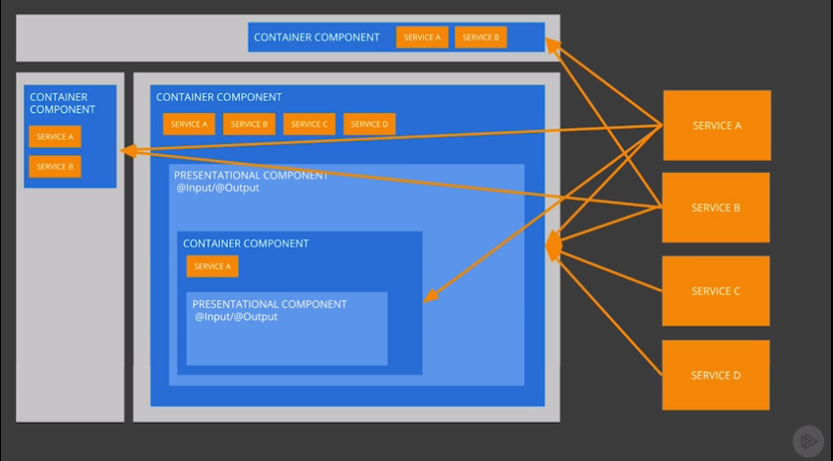

Solution:: 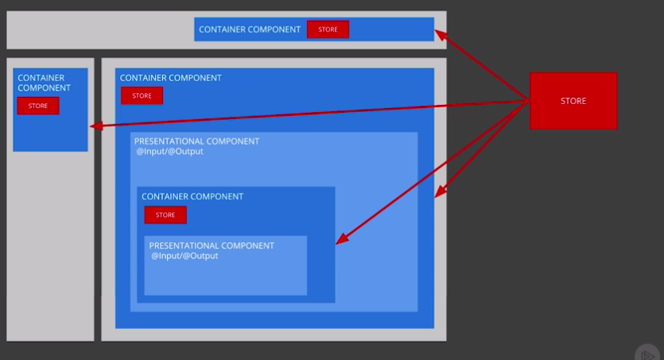

Store : just a java script object.

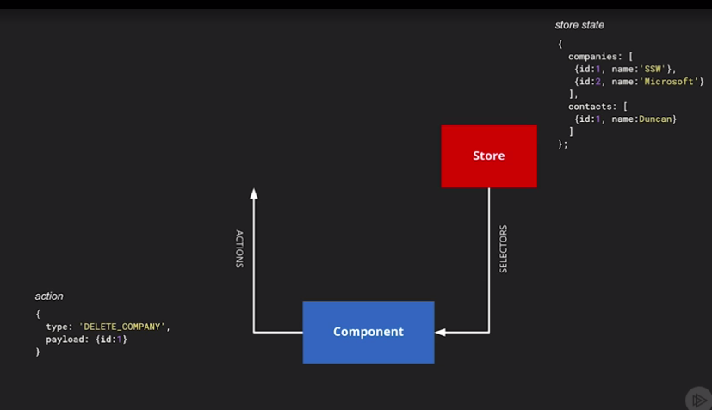

Reducers:

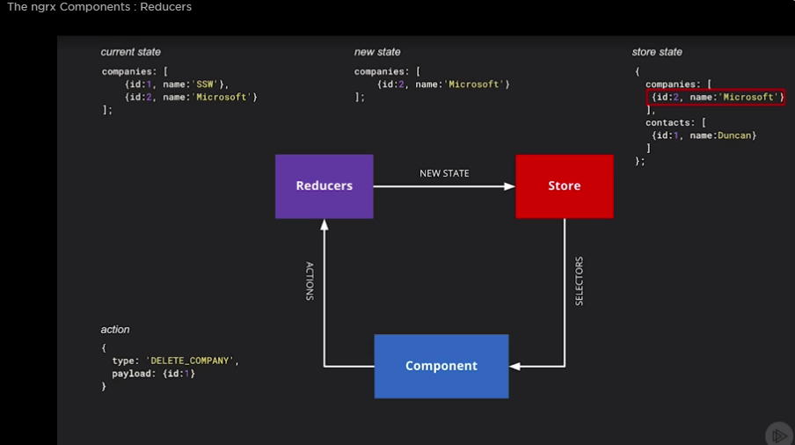

Pair function:

Effects:

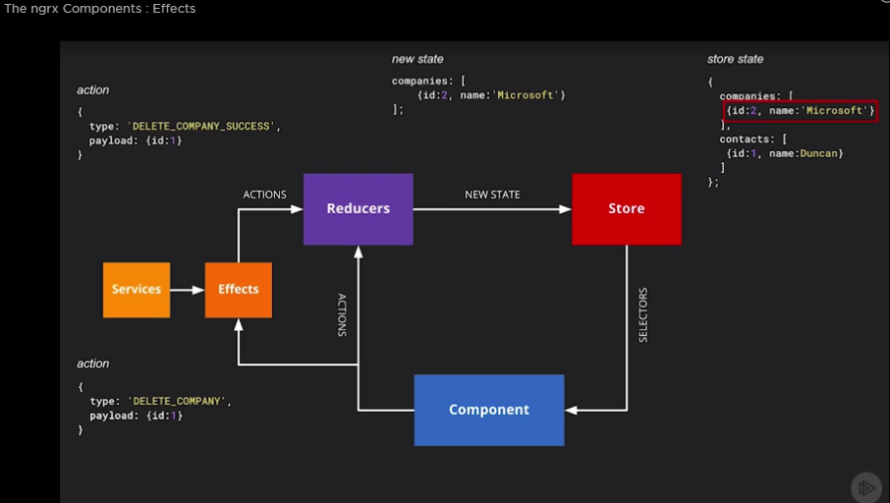

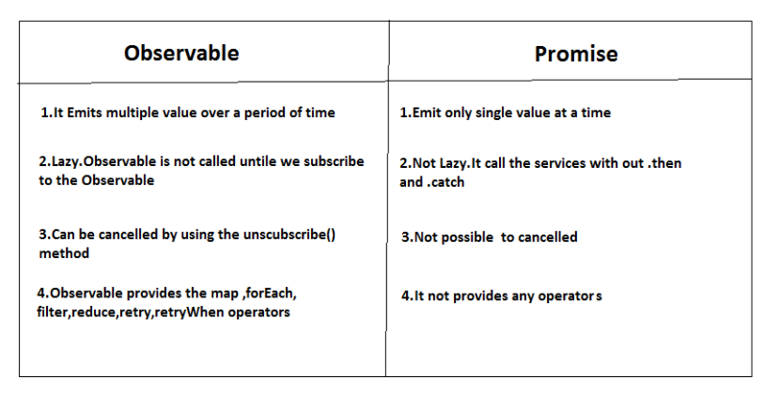

An Observable is like a **Stream** (in many languages) and allows to pass zero or more events where the callback is called for each event.

Often Observable is preferred over Promise because it provides the features of Promise and more. With Observable it doesn't matter if you want to handle 0, 1, or multiple events. You can utilize the same API in each case.

**promise:**

* having one pipe line
* usually only use with async data return
* not easy to cancel

**observable:**

* are cancellable
* are retriable by nature such as retry and retryWhen
* stream data in multiple pipe lines
* having array-like operations like map, filter etc
* can be created from other sources like events
* they are function, which could be subscribed later on

